# Linear Algebra Practical

1. Given the following traditional Cartesian planes, on the left one, draw the vectors **v** = (2, 1) and **w** = (-1, -2) on it. On the right Cartesian plane, draw the result of adding 2**v**+**w**.

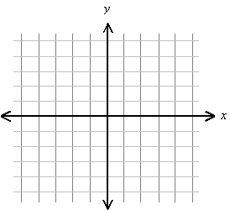

1. What is the length or 2nd norm (L2) of vector **z** = (3, 4)?
2. If $ϑ$ is 30 degrees and **a** = (3,4), what is the magnitude of the projection (a1) of **a** upon **b**?

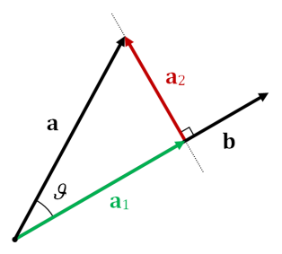

1. Given ***u*** = (5,2,3) and **v**=(1,-1,2), find *u*·v (the scalar product/inner product/dot product).
2. Let

$A=\left(\begin{matrix}4 & -1 \\ 6 & 9\end{matrix}\right)$ and $B=\left(\begin{matrix}0 & 3 \\ 3 & -2\end{matrix}\right)$

Find

(*i*)  *A* + *B*,

(*ii*) 2*A* − *B*

(*iii*)  *AB*

(*iv*)  *BA*

1. AT (the transpose of *A*)
2. Det(A) (the determinant of *A*)
3. tr(A) (the trace of *A*)
4. Let $A=\left(\begin{matrix}4 & -1 \\ 6 & 9 \\ 2 & 3\end{matrix}\right)$ and $B=\left(\begin{matrix}0 & 3 \\ 3 & -2\end{matrix}\right)$
5. Is *AB* defined? If it is defined, find it.
6. Is *BA* defined? How come?
7. What is the element A22 of A
8. What is the result of AI?
9. What is the result of BB-1?
10. Calculate the inverse of B, i.e. B-1
11. Manually calculate the result of BB-1
12. Draw the span of the vectors below



1. Are the following 2 vectors linearly dependent or independent? (Hint: plot them)



$$v=\left[\begin{matrix}1 \\ 2\end{matrix}\right] w=\left[\begin{matrix}2 \\ 4\end{matrix}\right]$$

1. The vectors i and j below are the basis vectors in some space. Can you draw the vector (1,1) in that basis?

j

i